ABSTRACT

This report represents a comprehensive analysis of various numerical methods employed to solve mathematical problems, their applications in real life and practical examples conducted by a collaborative group of six individuals. We employed both traditional hand calculations techniques and modern programming approaches like Matla to enhance our understanding of numerical analysis. The methods investigated include the Newton Raphson method, fixed point iteration, bisection method, secant and langrage method.
Each member contributed to the development and implementation of these techniques, allowing for a comparative assessment of accuracy, efficiency and ease of use.

DECLARATION

We hereby declare that the work presented in this report is our original work and has not been submitted for any other academic purpose. This report is a result of our own research and understanding of the numerical methods, formulation, implementation and applications.

ACKNOWLEDGEMENT

We would like to begin by expressing our heartfelt gratitude to Almighty God for granting us wisdom, strength and perseverance needed to complete this report
We also appreciate the collaborative spirit of our team members and all those who contributed to the successful completion of this report on numerical analysis.
GROUP 8

DEDICATION

We dedicate this report to all the inspiring mathematicians and engineers who strive to unlock the mysteries of numerical methods. May this inspire you to pursue knowledge with passion and determination.

LIST OF ABBREVIATIONS

i.e. that is to say.

TABLE OF CONTENT

ABSTRACT i
DECLARATION ii
ACKNOWLEDGEMENT iii
DEDICATION iv
LIST OF ABBREVIATIONS v
LIST OF TABLES vii
LIST OF FIGURES vii
LIST OF EQUATIONS vii
CHAPTER 1 1
  - METHODOLOGY 1
    - Arrangement of study 1
    - Organisation 1
    - Procedure of study 1
CHAPTER 2 2
  - STUDY COVERAGE 2
  - FIXED POINT ITERATION 2
    - USING MATLAB 3
    - APPLICATIONS 4
  - NEWTON’S METHOD 6
    - USING MATLAB 6
    - APPLICATIONS 7
  - SECANT METHOD 8
    - USING MATLAB 8
    - APPLICATIONS 9
  - LAGRANGE METHOD. 10
    - USING MATLAB 10
    - APPLICATIONS 11
  - BISECTION METHOD 13
    - USING MATLAB 13
    - APPLICATIONS 14
  - NUMERICAL METHOD AGAINST THE COMPUTATION TIME TAKEN IN MATLAB 15
  - DISPLAY OF THE FASTEST METHOD IN MATLAB 16
CHAPTER 3 17
  - DISCUSSION OF RESULTS PLOTTED 17
  - CONCLUSION 18
  - RECOMMENDATION 18
  - REFERENCES 19

LIST OF TABLES

Table 1 Shows a discussion timetable 1
Table 2 Shows simplification of secant method 8
Table 3 Shows values x and their corresponding values of f(x) 10
Table 4 Shows the solution to the above question using bisection method 13

LIST OF FIGURES
Figure 1 Shows the comparison of numerical methods with time taken 15

LIST OF EQUATIONS
Equation 1 Shows the Newton's Raphson Formula 6
Equation 2 Shows formula used in the secant method 8

CHAPTER 1

INTRODUCTION

METHODOLOGY
The information in this group report was achieved and collected through different preparations. It aims to explore the various numerical methods used in programming and their practical applications in solving real-life engineering problems. By examining real-world examples, we will explain the effectiveness of these methods, providing insights into their role in advancing engineering practices. Through collaborative research and analysis, we hope to contribute to a deeper understanding of how numerical methods can be harnessed to tackle contemporary engineering challenges.
    - Arrangement of study
The programming class was divided into six groups i.e. A, B, C, D, E, F, G, H, I, J, K, L, M, N, O, P, Q, R, S, T and each group was required to research on the various numerical methods and their practical application in engineering.
    - Organisation
Every member of Group K was assigned to make research on a specific numerical method relevant to programming which included fixed point iteration, Newton’s method, secant, bisection and Lagrange method.
    - Procedure of study
Immediately after the grouping, we created a WhatsApp group which united us all as per group K members.
We made a time table for our meeting after class to check on each others progress.

Table 1 Shows a discussion timetable

DATE | TIME
13TH September ,2024 | 4:30pm-6:00pm
14TH September ,2024 | 4:30pm-6:00pm
15TH September ,2024 | 4:30pm-6:00pm
16TH September ,2024 | 4:30pm-6:00pm
17TH September ,2024 | 4:30pm-6:00pm
18TH September ,2024 | 4:30pm-6:00pm

1

CHAPTER 2

STUDY COVERAGE
The purpose of the study was to enable students appreciate how crucial numerical methods are in approximating solutions to mathematical problems that can not be solved analytically.
This is especially true in engineering, where real world scenarios often involve complex equations.

FIXED POINT ITERATION
Use the fixed point iteration method to find root of this equation 2𝑥³ − 2𝑥 − 5 = 0 correct up to 4 decimal places. Use 𝑥₀ = 1.5
2𝑥³ − 2𝑥 − 5 = 0

1
2𝑥 + 5 3
𝑥 = ( ) 2

1
2𝑥 + 5 3
𝑔(𝑥) = ( ) 2
𝑥_{𝑖+1} = 𝑔(𝑥_{𝑖}) ; 𝑖 = 0,1,2 …

𝑊ℎ𝑒𝑟𝑒 𝑥₀ = 1.5

1st Iteration : i=0

𝑥₁ = 𝑔(𝑥₀)

1
2(1.5) + 5 3
𝑥₁ = ( 2 )
𝑥₁ = 1.5874

2nd Iteration: i =1

𝑥₂ = 𝑔(𝑥₁)

1
2(1.5874) + 5 3
𝑥₂ = ( 2 )
𝑥₂ = 1.5989

3rd Iteration: i=2

𝑥₃ = 𝑔(𝑥₂)

1
2(1.5989) + 5 3
𝑥₃ = ( 2 )
𝑥₃ = 1.6004

4th Iteration: i=3

𝑥₄ = 𝑔(𝑥₃)

1
2(1.6004) + 5 3
𝑥₄ = ( 2 )
𝑥₄ = 1.6006

5th Iteration: i=4

𝑥₅ = 𝑔(𝑥₄)

1
2(1.6006) + 5 3
𝑥₅ = ( 2 )
𝑥₅ = 1.6006

The approximate root of the equation 2𝑥³ − 2𝑥 − 5 = 0 is 1.6006 (4dp)

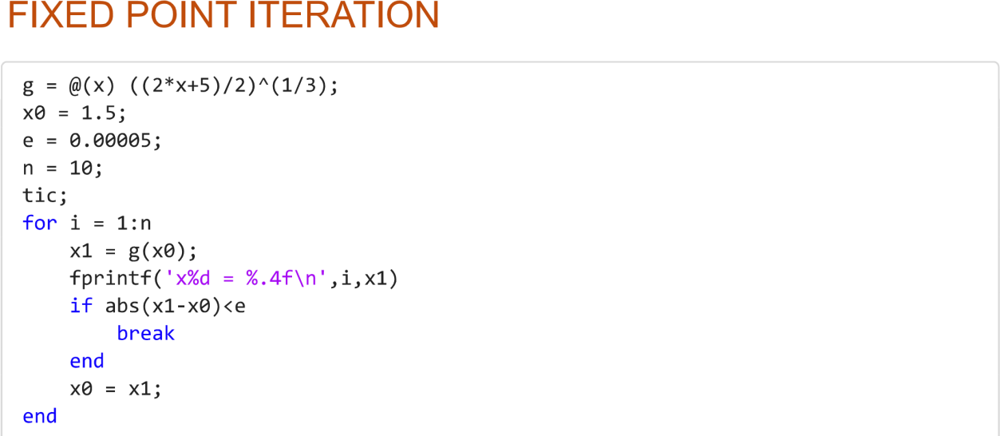
USING MATLAB

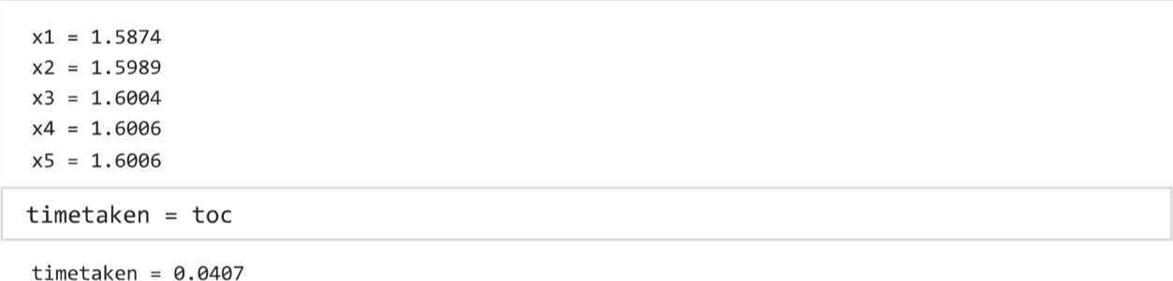

APPLICATIONS
In economics, it is used to find equilibrium points in models where supply equals demand. For example, in cobweb model which describes how prices of goods in a competitive market adjust over time, the method helps to approximate the equilibrium price by repeatedly substituting the current price into a demand supply equation until convergence.
In electrical engineering, it is used to power flow problems which determines the voltage and current distribution in grids. For example, the gauss seidel method which helps in solving non linear equations representing load flow, calculating the voltage at each node
In the chemical engineering, it is used to design and optimize reactors through solving energy balance equations. For example, in a continuous stirred tank reactor where the reaction depends on temperature the method is used to determine the steady state concentration of reactants and products in the reactor.
In the environmental science, the method is used in determining modelling populations dynamics where there is a relationship between the future and current population. For example, in logistic population growth, the method helps to approximate the stable population sizes in environment with limited resources which helps scientists to predict how a population will stabilize over time.
In robotics, it used in inverse kinematics to calculate the required joints angles for a robotic arm to reach a specific positions. For example, a robot arm with several joints needs to move its end effector to a particular point hence the need to use the iteration method to find the joint angles iteratively which enables it to reach the desired location precisely.
In robotics, it used in inverse kinematics to calculate the required joints angles for a robotic arm to reach a specific position. For example, a robot arm with several joints needs to move

its end effector to a particular point hence the need to use the iteration method to find the joint angles iteratively which enables it to reach the desired location precisely.

NEWTON’S METHOD
Use Newton’s Raphson method to find the root of the equation 𝑥³ + 𝑥 − 1 = 0, using 𝑥₀ =
0.5 as the initial approximation, correct your answer to 2 dps.

𝑓(𝑥) = 𝑥³ + 𝑥 − 1

𝑓′(𝑥) = 3𝑥² + 1
𝑓(𝑥_{𝑛})
𝑥𝑛+1 = 𝑥𝑛 − 𝑓′(𝑥 )
𝑛

Equation 1 Shows the Newton's Raphson Formula
2𝑥_{𝑛}³ + 1

𝑥𝑛+1 = 3𝑥
𝑛
2 + 1

𝑥₀ = 0.5

2(0.5)³ + 1
𝑥1 = 3(0.5)² + 1

𝑥₁ = 0.7142

2(0.7142)³ + 1
𝑥2 = 3(0.7142)² + 1

𝑥₂ = 0.6831

2(0.6831)³ + 1
𝑥3 = 3(0.6831)² + 1

𝑥₃ = 0.6824

|0.6824 − 0.6831| < 0.005

Root is 0.68

USING MATLAB
NEWTON RAPHSON'S METHOD
f = @(x) (x^3)+x-1; df = @(x) 3*(x^2)+1; e = 0.005;
x0 = 0.5;
x = x0; tic;

while abs(f(x)) >= e
x = x - f(x)/df(x);
end
fprintf('calculate root: %.2f\n',x)
calculate root: 0.68
timetaken = toc
timetaken = 0.0392

APPLICATIONS
      - Used for solving non linear equations in structural analysis of deformations of stress in structures, especially under larger load. For example, in finite element analysis of a bridge or building, the relationship between the applied forces and the resulting displacement.
      - Used in power system analysis and circuit design to solve non linear equations related to electrical systems. For example, in the flow analysis, the goal is to find the voltages in an electrical grid which involves the use of this method to obtain an accurate grid.
      - Used in physics to find equilibrium points or solve equations that describe physical systems. For example, in orbital mechanics when calculating the orbits of celestial bodies
Kepler’s equations to determine the position of the planet in its elliptical orbit.
      - Used in computer graphics to solve intersection problems such as finding the points where rays intersect objects. For example, in ray tracing, it creates realistic images, light rays which are projected into a scene and their intersections with surfaces are calculated.
      - Used in finance to solve for unknown interest rates, yields in bonding pricing and investment scenarios. For example, when pricing a zero coupon bond the price is related to the yield to maturity through the non- linear equations hence need for the method to solve yield to maturity prices.
      - Used in geotechnical engineering to solve the equation involved in analysing slope stability. For example, in analysis of slope stability, the slope has geometry and external forces which requires the use of method to solve for the factor of safety which predicts whether a slope will fail or remain stable under load.

SECANT METHOD
Use the secant method to solve the function x^3-5x+1=0 for x0=0 and x1=1 to 4 dps
𝑓(𝑋𝑛)(Xn − Xn − 10)
𝑿𝒏 + 𝟏 = 𝑋𝑛 −
𝑓(𝑋𝑛) − 𝑓(𝑋𝑛 − 1)
Equation 2 Shows formula used in the secant method
Dn=f(Xn)(Xn-Xn-1)
Nn= f(Xn)- f(Xn-1)
Table 2 Shows simplification of secant method

n | Xn-1 | Xn | Nn | Dn | Xn+1 | |Xn-Xn-1|
0 | 0 | 1 | -3 | -4 | 0.25 | 0.75
1 | 1 | 0.25 | 0.17578 | 2.765625 | 0.1864 | 0.0636
2 | 0.25 | 0.1864 | -0.004736 | 0.3089 | 0.2017 | 0.015
3 | 0.1864 | 0.2017 | 0.0000045 | -0.07477 | 0.2016 | 0.00006

X= 0.2016

USING MATLAB SECANT METHOD
f=@(x)x^3-5*x+1; x0=0;
x1=1;
tic;
for i=1:100
x2=x1-(f(x1)*(x1-x0)/(f(x1)-f(x0))); if abs(x2-x1)<0.0005
break;
end x0=x1; x1=x2;
end
disp(x2)
0.2016
timetaken=toc
timetaken = 0.0145

APPLICATIONS

Structural Analysis

Engineers often need to determine the load-bearing capacity of structures. This involves solving nonlinear equations that describe the relationship between loads and deformations.
When analysing a beam under various loads, the equation representing the deflection might be nonlinear. The secant method can be used to find the load at which the deflection reaches a critical threshold, indicating potential failure.

Fluid Mechanics

In fluid dynamics, engineers frequently deal with equations that describe flow behaviour, such as the Bernoulli equation or Navier-Stokes equations.
When calculating the pressure drop in a pipe system, engineers may need to solve for flow rates or velocities that satisfy certain conditions. The secant method can help find these values by iteratively refining estimates based on previous calculations.

Electrical Engineering

In circuit design, engineers need to analyse complex circuits that include nonlinear components (like diodes and transistors).
The current-voltage relationship in a diode is nonlinear. To find the operating point of a circuit, engineers can use the secant method to solve the equation that represents the circuit's behaviour, allowing them to optimize performance.

LAGRANGE METHOD.
Given a certain unknown function f(x) has the following values at corresponding x-values;

Table 3 Shows values x and their corresponding values of f(x)
x
1
1.2
1.3
1.5
f(x)
0.368
0.301
0.273
0.223
Use Lagrange interpolation to find f(1.4).

f(x)= [(x-x2)(x-x3)(x-x4)/(x1-x2)(x1-x3)(x1-x4)]y1+[(x-x1)(x-x3)(x-x4)/(x2-x1)(x2-x3)(x2-
x4)]y2 +[(x-x1)(x-x2)(x-x4)/(x3-x1)(x3-x2)(x3-x4)]y3 +[(x-x1)(x-x2)(x-x3)/(x4-x1)(x4- x2)(x4-x3)]y4
f(x)=[(x-1.2)(x-1.3)(x-1.5)/(1-1.2)(1-1.3)(1-1.5)](0.368) +[(x-1)(x-1.3)(x-1.5)/(1.2-1)(1.2-
1.3)(1.2-1.5)](0.301) +[(x-1)(x-1.2)(x-1.5)/(1.3-1)(1.3-1.2)(1.3-1.5)](0.273) +[(x-1)(x-1.2)(x-
1.3)/(1.5-1)(1.5-1.2)(1.5-1.3)](0.223) f(x)=-0.167x³ + 0.767x² -1.415x +1.183 f(1.4)=0.2473

USING MATLAB
x=[1 1.2 1.3 1.5]
x = 1×4
1.0000 1.2000 1.3000 1.5000
y=[0.368 0.301 0.273 0.223]
y = 1×4
0.3680 0.3010 0.2730 0.2230
n=3
n = 3
xp=1.4
xp = 1.4000
sm=0
sm = 0
tic;
for i=1:n+1 pr=1
for j=1:n+1
if j~=i
pr=pr*(xp-x(j))/(x(i)-x(j));
end

end
sm=sm + y(i)*pr
end
pr = 1
sm = 0.0245
pr = 1
sm = -0.1761
pr = 1
sm = 0.1879
pr = 1
sm = 0.2473
yp=sm
yp = 0.2473
timetaken=toc
timetaken = 0.0163

APPLICATIONS

Data Fitting and Curve Approximation

Engineers often collect experimental data that need to be analyzed or predicted. Lagrange interpolation helps create a polynomial that fits these data points.
In structural engineering, when testing materials under various loads, engineers gather stress- strain data. Lagrange interpolation can be used to estimate the stress at intermediate strain values, allowing for better understanding and predictions of material behavior.

Computer-Aided Design (CAD)

In CAD software, designers often need to create curves and surfaces that pass through specific points. Lagrange interpolation can be used to construct these curves.
When designing a car body, engineers may have a set of points representing the desired shape. Using Lagrange interpolation, they can create a smooth curve that passes through these points, ensuring that the design meets aesthetic and aerodynamic requirements.

Control Systems

In control engineering, system responses are often modeled based on sampled data. Lagrange interpolation can be used to estimate system behavior between these samples.
When tuning a PID controller, engineers may have discrete measurements of system response. By applying Lagrange interpolation, they can predict how the system will behave at unmeasured points, aiding in optimizing controller parameters.

Finite Element Analysis (FEA)

In FEA, engineers analyse complex structures by breaking them down into smaller elements. Lagrange polynomials are often used to interpolate the solution over these elements.
In analysing a bridge under load, engineers might use Lagrange interpolation to estimate stress distribution across the bridge’s surface based on nodal values obtained from simulations.

BISECTION METHOD
Use bisection method to prove the root of f(x) =𝑥⁴ + 𝑥 − 1 lies between (0.5, 1.0) and correct your answer to 2decimal places.
Table 4 Shows the solution to the above question using bisection method

n | 𝒙_{𝟏} | 𝒙_{𝟐} | 𝒙_{𝒏} | f(𝒙_{𝟏}) | f(𝒙_{𝟐}) | f(  𝒙_{𝟏}) 𝐟(𝒙_{𝟐}) | Interval | |tol|
1 | 0.5 | 1.0 | 0.75 | -0.4375 | 1 | <0
2 | 0.5 | 0.75 | 0.625 | -0.4375 | 0.0664 | <0 | 0.5<x<0.75 | 0.125
3 | 0.625 | 0.75 | 0.6875 | -0.2224 | 0.0664 | <0 | 0.625<x<0.75 | 0.0625
4 | 0.6875 | 0.75 | 0.71875 | -0.08939 | 0.0664 | <0 | 0.6875<x<0.75 | 0.03125
5 | 0.71875 | 0.75 | 0.734375 | -0.01437 | 0.0664 | <0 | 0.71875<x<0.75 | 0.015625
6 | 0.71875 | 0.73437 | 0.7265625 | -0.01437 | 0.0252 | <0 | 0.71875<x<0.73437 | 0.0078125
7 | 0.71875 | 0.7265625 | 0.72265625 | 0.01437 | 0.005236 | >0 | 0.71875<x<0.7226562  5 | 0.0039
Therefore, the root of the equation is 0.72 (2dps)

USING MATLAB
f=@(x)x.^4+x-1; a=0;
b=1;
tol=1e-3; tic;
while(b-a)>tol c=(a+b)/2;
if f(c)==0 break;
elseif f(a)*f(c)<0 b=c;
else
a=c;
end end
root=(a+b)/2; disp(['Root',num2str(root)]);
Root0.72412

timetaken = toc
timetaken = 0.0284

APPLICATIONS

Circuit Design:

In electrical engineering, the bisection method is used to find the operating points in non- linear circuits, especially when designing circuits with diodes and transistors.

Root Finding in Physics;

Projectile Motion: In problems of projectile motion where a specific time or height is needed, but the governing equations are complex, the bisection method can be used to solve for time or distance.
Orbital Mechanics: The bisection method is used to determine the solution to Kepler's equation, which is critical in determining planetary orbits.

Control Systems;
Stability Margins: Control engineers use the bisection method to determine stability margins in feedback systems. The system’s characteristic equation may be complex, and the bisection method helps in identifying the point where the system transitions from stable to unstable.

Finance;
Option Pricing: The bisection method can be applied in financial modeling, particularly when solving for the implied volatility in options pricing models like the Black-Scholes formula.
Implied volatility is the volatility that makes the model price match the market price of an option.

Thermodynamics and Fluid Dynamics;
Heat Transfer Problems: The bisection method is used to find temperatures at specific points in complex heat transfer problems. It is also applied to solve for boundary conditions in problems involving steady-state heat conduction.
Flow Problems: The method is used in fluid dynamics to determine critical flow parameters like pressure or velocity, especially when solving for flow rates in pipes with non-linear relationships (e.g., through the Darcy-Weisbach equation).

Computer Graphics and Game Development;
Ray Tracing: The bisection method is used in computer graphics, especially in ray tracing algorithms, to find points of intersection between rays and objects in a scene.
Collision Detection: It is used in real-time physics engines for games to detect when and where objects will collide.

NUMERICAL METHOD AGAINST THE COMPUTATION TIME TAKEN IN MATLAB

methods = {'Fixed point iteration','Newtons','Secant','Lagrange','Bisection'}; timetaken = [0.0407, 0.0392, 0.0145, 0.0163, 0.0284];
bar(categorical(methods), timetaken) hold on
xlabel ('method'); ylabel('timetaken(seconds)'); title('Comparison of methods by time taken') grid on

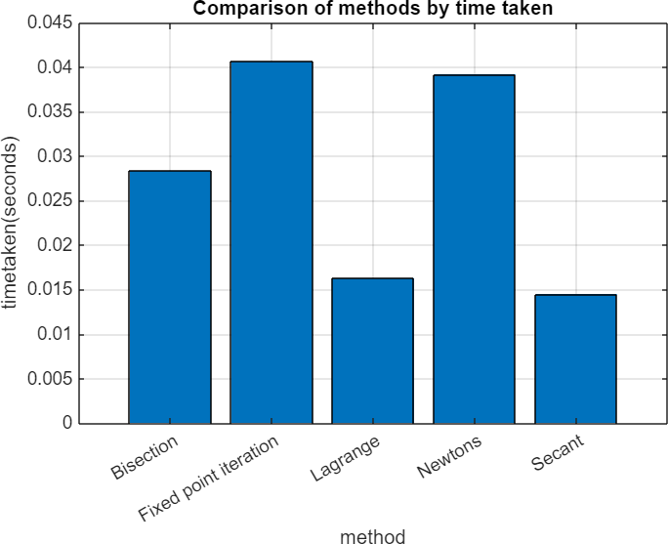
Figure 1 Shows the comparison of numerical methods with time taken

DISPLAY OF THE FASTEST METHOD IN MATLAB
% determining the fastest method to find any root. [~,indx]= min(timetaken);
fastest_method= methods(indx); disp(['fastest method:';fastest_method ])
{'fastest method:'}
{'Secant' }

CHAPTER 3

DISCUSSION OF RESULTS PLOTTED
Due to the limited time given to accomplish this task, we decided to only compare the computation time as per fixed point, Newton’s, Secant, Langrage, and bisection methods used in the chosen examples.
From the graph of comparison of methods and time taken in MATLAB, we were able to deduce the fastest method which arrived at the answer irrespective of the few examples tested and this was Secant method
The secant method has a convergence rate that is super linear, specifically it converges quadratically when close to the root. This means that as the iterations progress, the number of correct digits in the approximation doubles with each step.
In contrast, the bisection method has linear convergence, meaning it reduces the interval by half with each iteration, which can be slower. Fixed-point iteration can also have slow convergence depending on the function's characteristics.

CONCLUSION
While the secant method can be faster than other methods in certain scenarios, its important to note that its performance can depend on the choice of the initial guesses and the nature of the function being analysed. Each method has its strengths and weakness, making them suitable for different types of problems.

RECOMMENDATION
We recommend Engineers to assess the characteristics of their specific problem before choosing the most suitable numerical method for their solution.

REFERENCES
Numerical methods for Scientific and Engineering Computation (R.K. Jain) Introduction to numerical analysis (Josef Stoer)
The art of scientific Computing (William. H. Press) Numerical Methods for Engineers (Steven C. Chapra)
Conte Samuel D. & Carl de Boor: Elementary N A and Algorithmic Approach 3rd edition 2005.
Financial Modelling with MATLAB by Robert Tatman

